HTML Crash Course

* <!DOCTYPE html>
  + Found at top of page, signifies type of html, this is for html 5
* <html>
  + Inside html tag, you will have:
    - <head>
      * <title> tag
        + Used to title the html document
    - <body>
  + Within bogy tag, there is a:
    - <header>
    - <footer>
* Comments
  + Can be done with <!—“Text” -->
* Headings:
  + <h1> Larger text and adds padding around
  + <h2> Little smaller than h1 however has some padding
  + <h3> - <h6> continues to grow smaller and smaller
* Paragraphs
  + <p> Has text demonstrated in paragraph form
* Margin is spacing around the element
  + Margin-before represents the margin above
  + Margin-after represents the margin below
  + Margin-start represents the margin to the left
  + Margin-end represents the margin to the right
* Inline vs. block level elements
  + Inline
    - Do not start on a new line
    - Take only the necessary width
    - <span>, <img>, <a>
  + Block
    - Start on a new line
    - Take full width available
    - <div>,<h1>-<h6>,<p>,<form>
* Font Changing
  + <strong> Makes text within strong tag bold
  + <em> Emphasizes the text within the em tag, normally is italic, can be changed with CSS
  + <a> - Links some text to another website
    - Href represents the location in which the link will carry to
    - Ex: <a href=<http://google.com>> target=”_blank”>Google</a>
    - Target=”_blank”> makes the link open in another tab
* Tag Attributes
  + All tags can have attributes
  + Provide information about an element
  + Placed within the start tag
  + Key/value pairs (id=”someId”)
  + Example:
    - <h1 title=”My Company”>About Us</h1>
* Lists
  + <ul>
    - Unordered lists and within has tags of <li>
    - Examples <li>List Item 1</li>
  + <ol>
    - Ordered list, same deal with tags of <li>
    - Has numbers instead of dots
* Table
  + <thead>
    - Gives the headings of each column and can be done with
    - <tr> Meaning table row
      * <th>Name</th> will put out a <th> for each header item
  + <tbody>
    - Represents the body of the table
    - <tr> Again needed for each row of a table
      * <td>Aidan Spelman</td> representing a certain item in the table
    - Can use multiple tr tags for each row needed
  + Can be edited with CSS to look better
* Forms
  + <form action=”process.php” method=”POST”>
  + Action submits the form to a certain page
  + Method makes a post request to a server, adding data to a database safe and secure
    - Get submits it and you will see the data on the URL such as a search
  + <label>
  + <input type=”text” name=”first-name” placeholder=”Enter first name”>
    - A lot of different inputs with a common one of text
    - Placeholder means that when clicking on it the Enter first name will go away
    - If submitting to a php file the name represents how you would grab the value
  + <input type=”email” name=”email”>
    - Makes the input type an email instead of a text
  + Select lists
    - <select name=”gender”>
      * <option value=”male”> Male</Option>
      * <option value=”female”> Female</Option>
      * Select will allow the user to choose between a select amount of options available to them
  + Other input types:
    - <input type=”number” name=”age” value=”30”>
      * 30 is the originating age but can be changed
    - <input type=”date” name=”birthday”>
    - <input type=”submit” name=”submit” value=”Submit”>
  + Using divs, because they’re block level elements can put forms on different lines
* Buttons
  + <button>Click Me</button>
    - Wont do anything, needs JavaScript to work
* Images
  + <img src=”sample.jpg alt=”My Sample Image” width=”200” height=”200”>
    - Src will call where the image is, must call to the exact location
    - Alt will display whatever text is there if the image is not found
    - Width will make the image 200px
    - Height also, will make the image 200 px
  + Also, you can put the image in an a tag and when clicked would be opened to a larger version
* Can use <br> to add another line
  + Also, and <hr> line will add a line horizontally across the page
* Quotations
  + <blockquote cite=<http://media.com>>
    - Cites the website and uses a blockquote
  + <abbr title=”World Wide Web”>WWW</abbr>
    - Abbreviation tag, shows WWW but when hovered it represents World Wide Web
* HTML5 Semantic Tags
  + A semantic element clearly describes its meaning to both the browser and the developer
  + 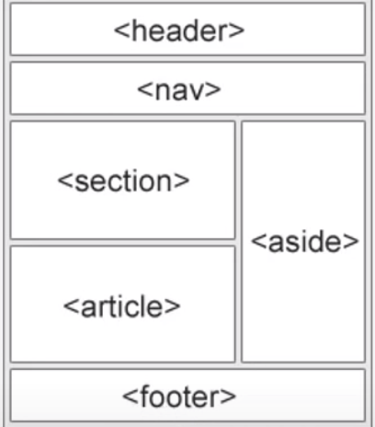
  + Used to structure a document further
* <nav> Used to be grabbed onto and styled in CSS when listing things
* &copy; will also give the copyright symbol
* <meta name=”animal” content”Dog”>
  + Content represents the description of the name